Resiliency : Load balancer only distribute traffic to healthy instances.

Load balancer can distribute trafic to multiple zones and multiple regions.

Creating Load Balancer Demo

Type Load Balancing

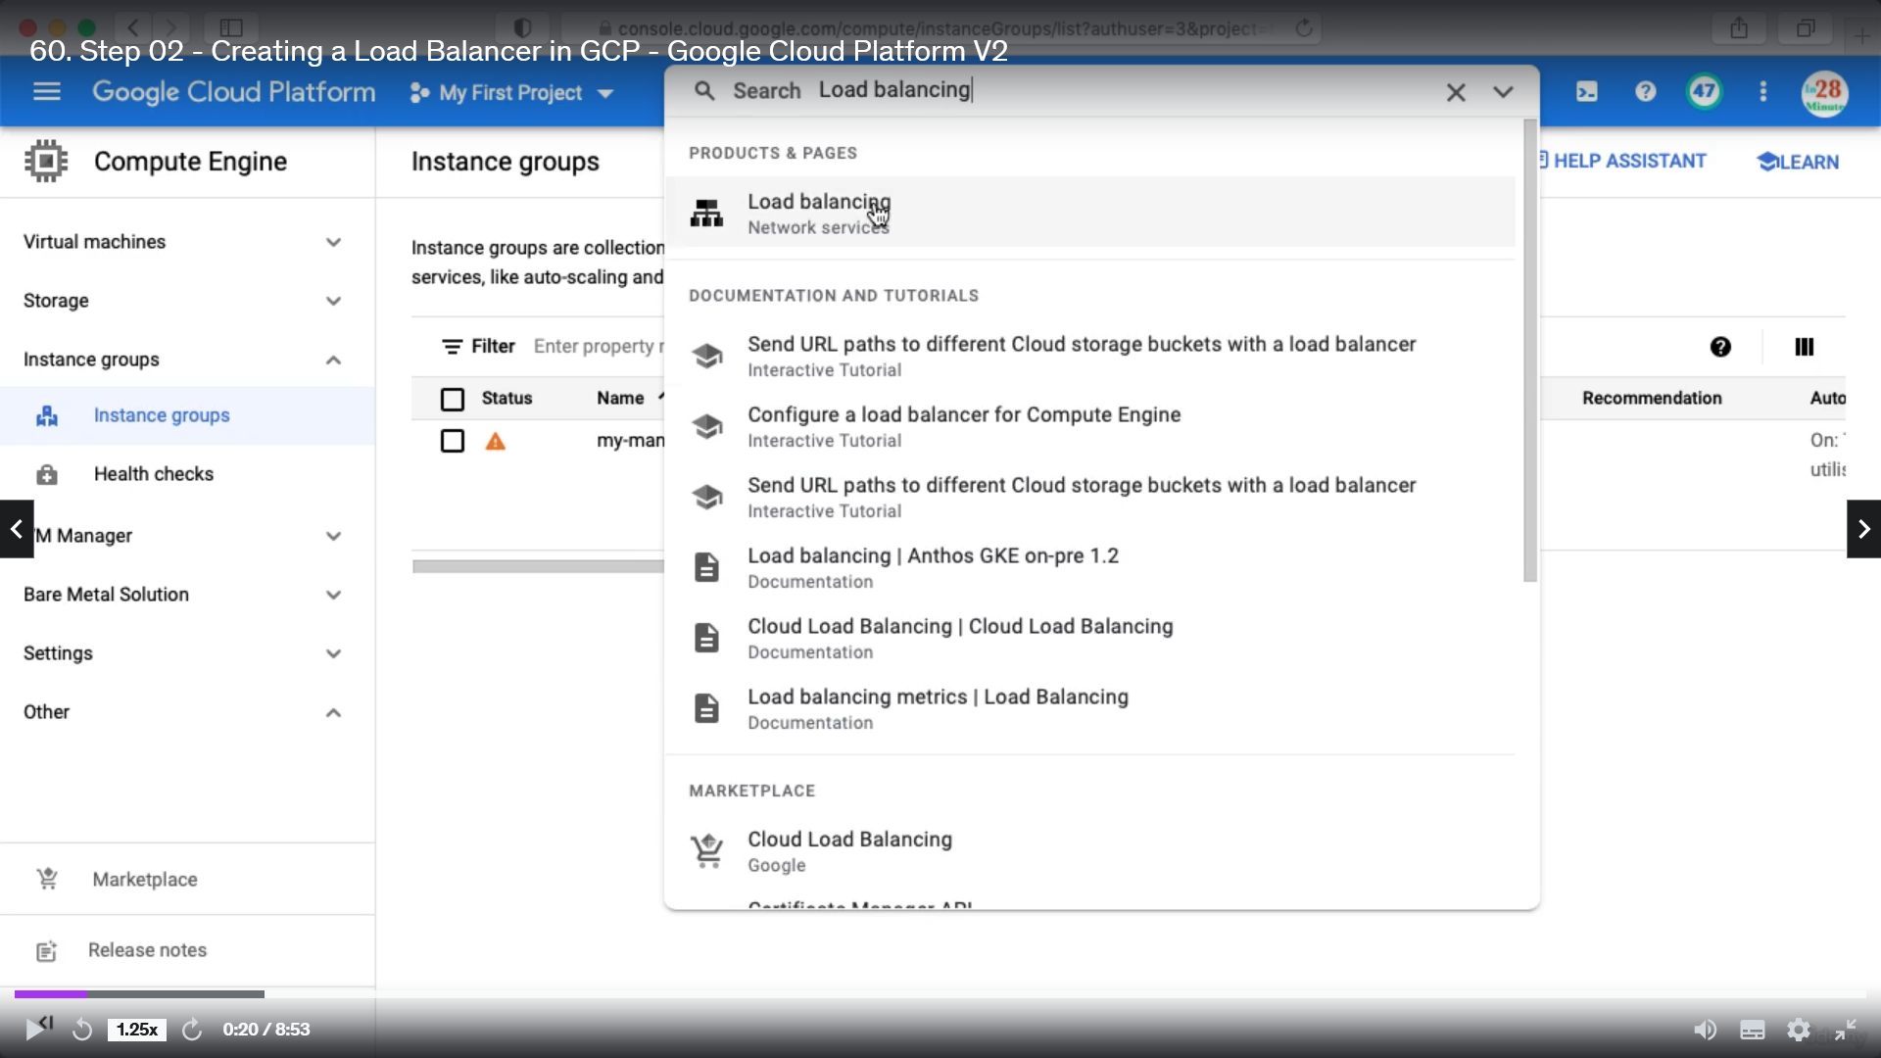

Click create Load Balancer

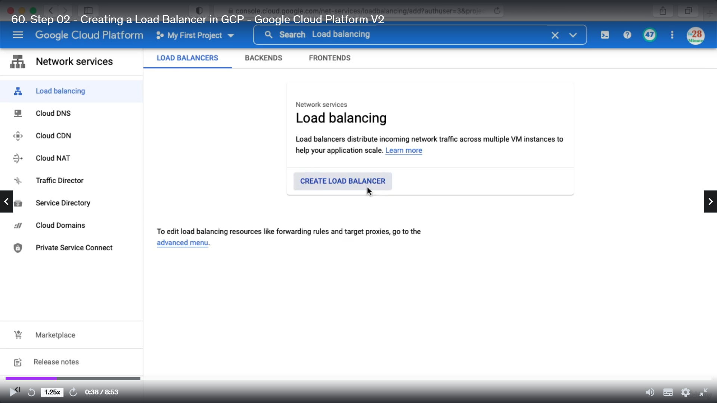

Below are the different type of load balancer

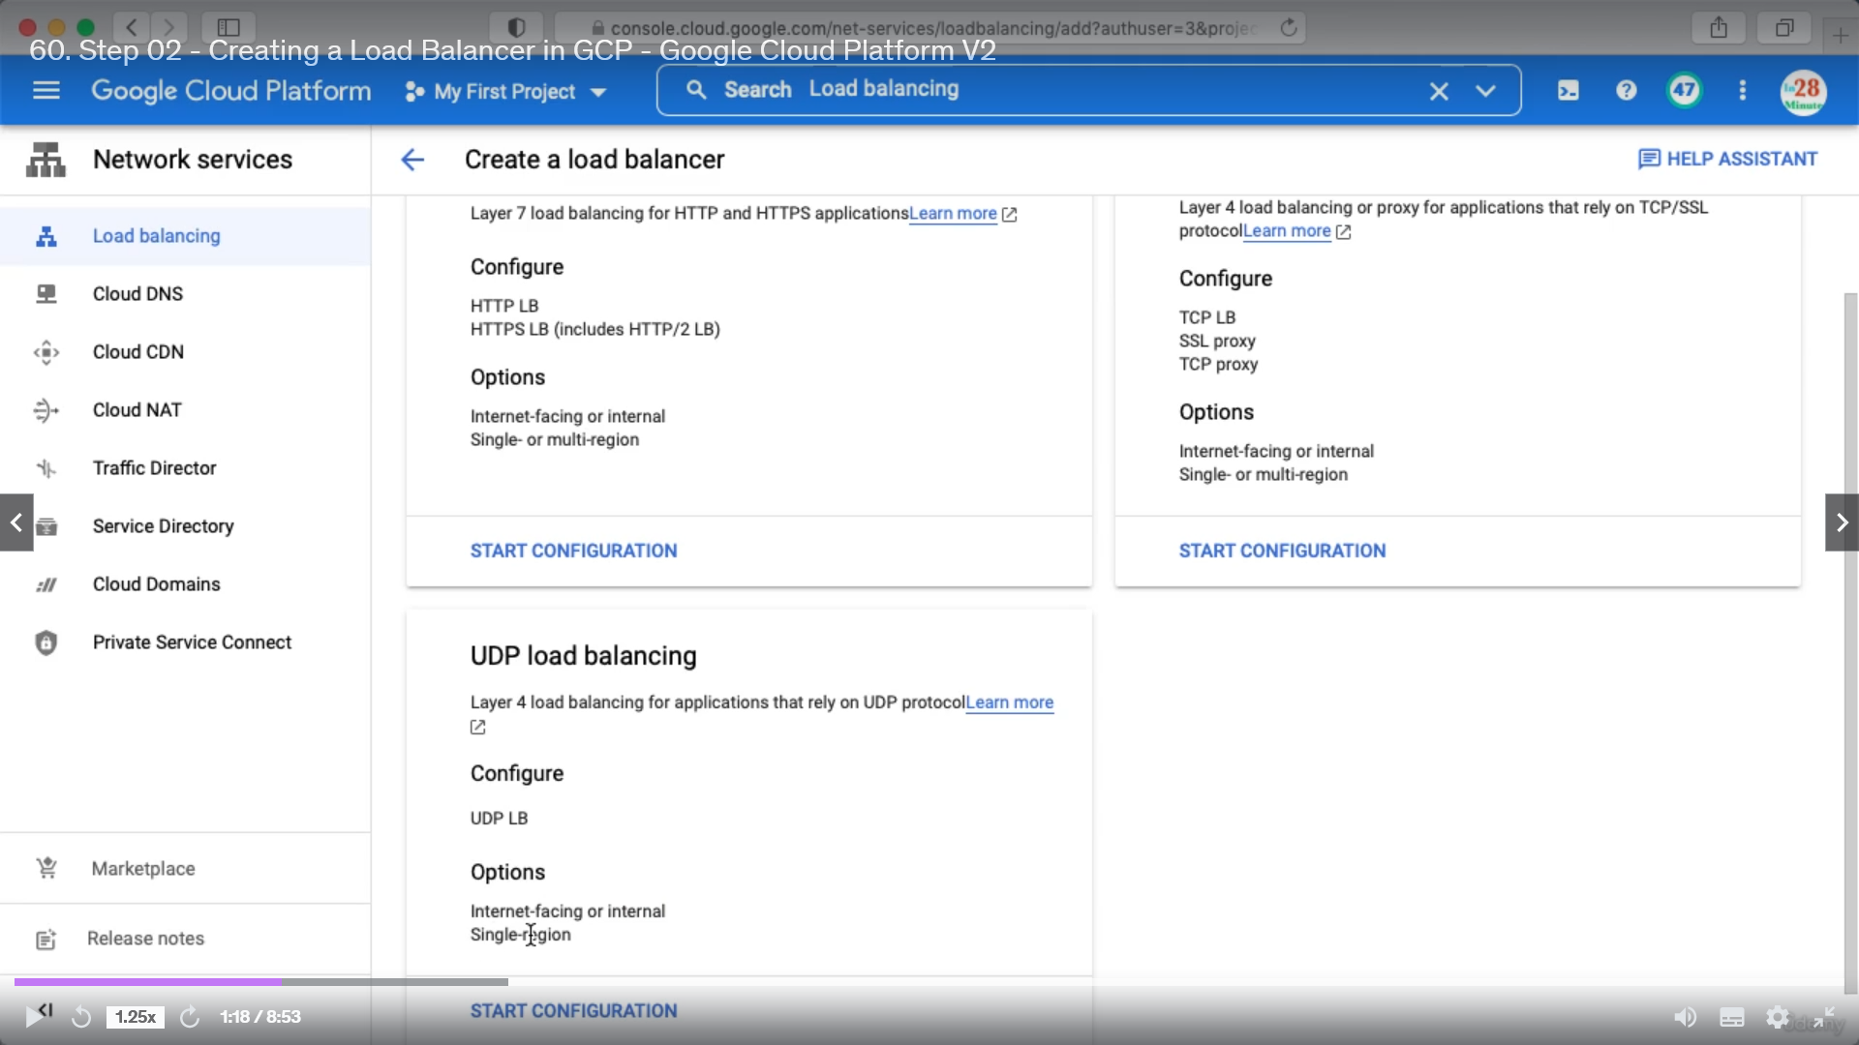

Gaming applications require high performance and they use TCP.

Click Start Configuration

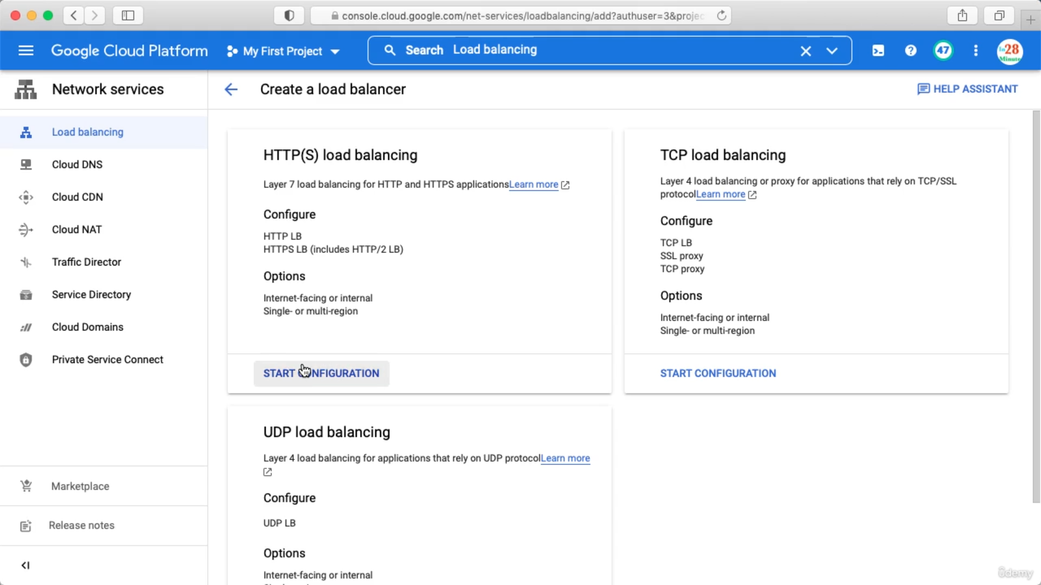

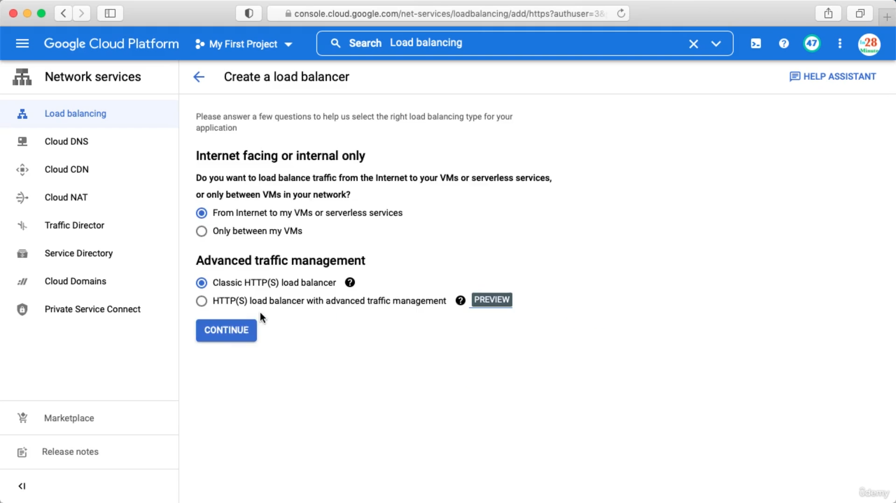

Click continue

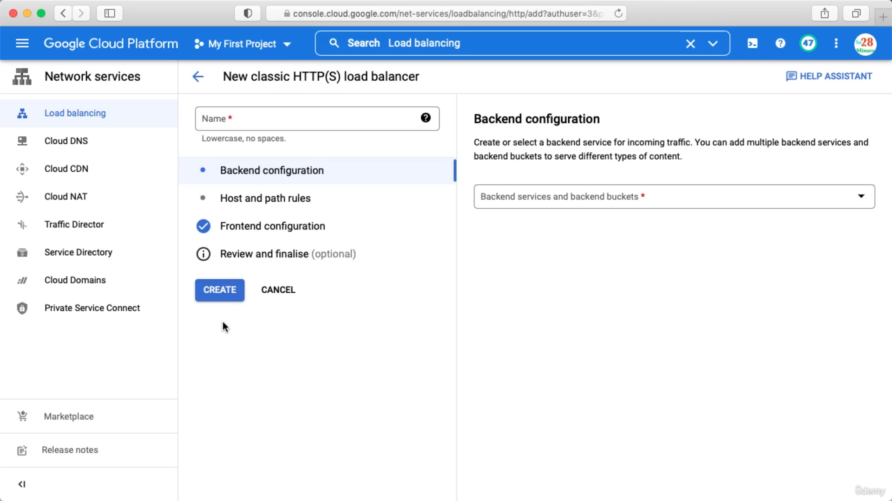

Now, Backend configuration means where you want to send the traffice

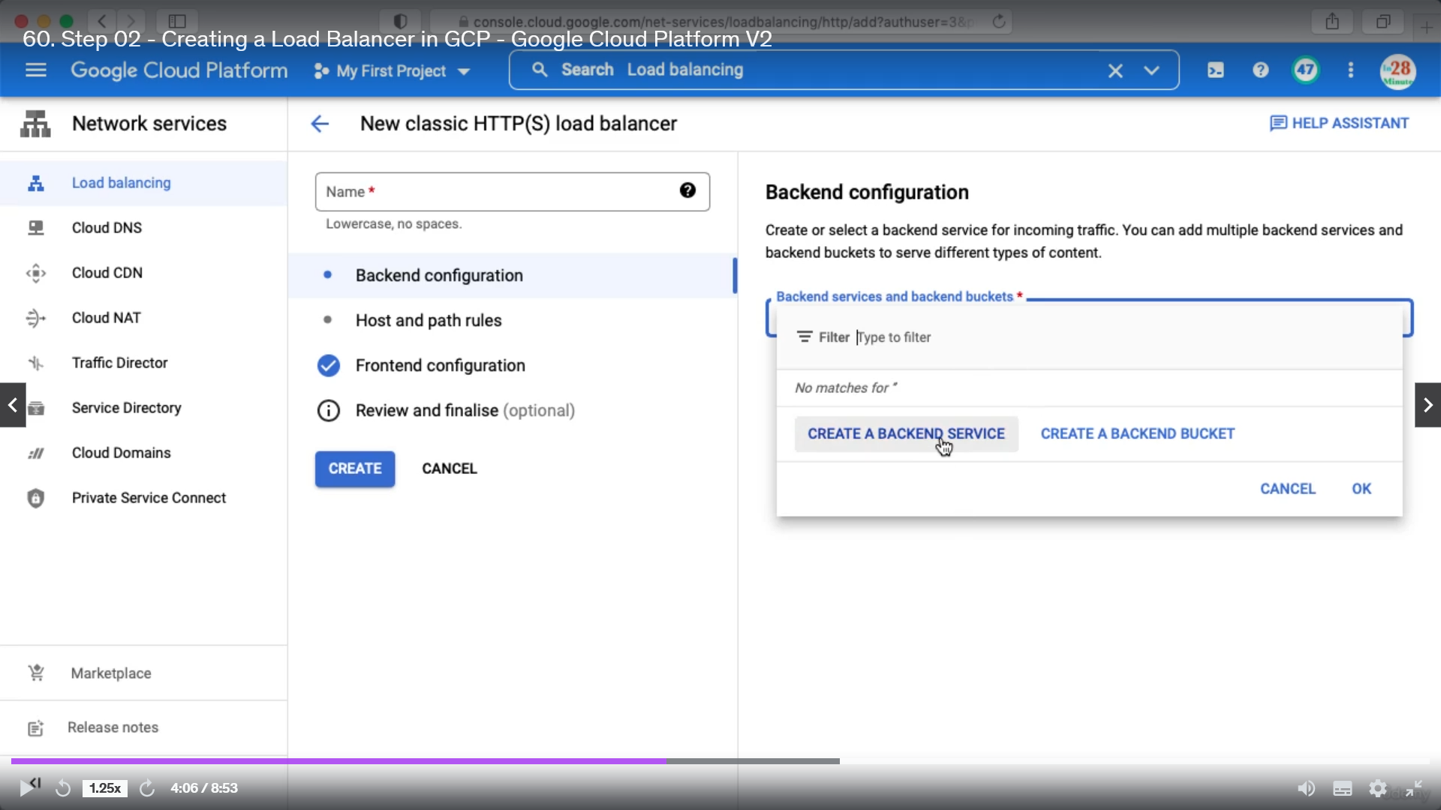

Click (Create a backend Service)and fillup below details

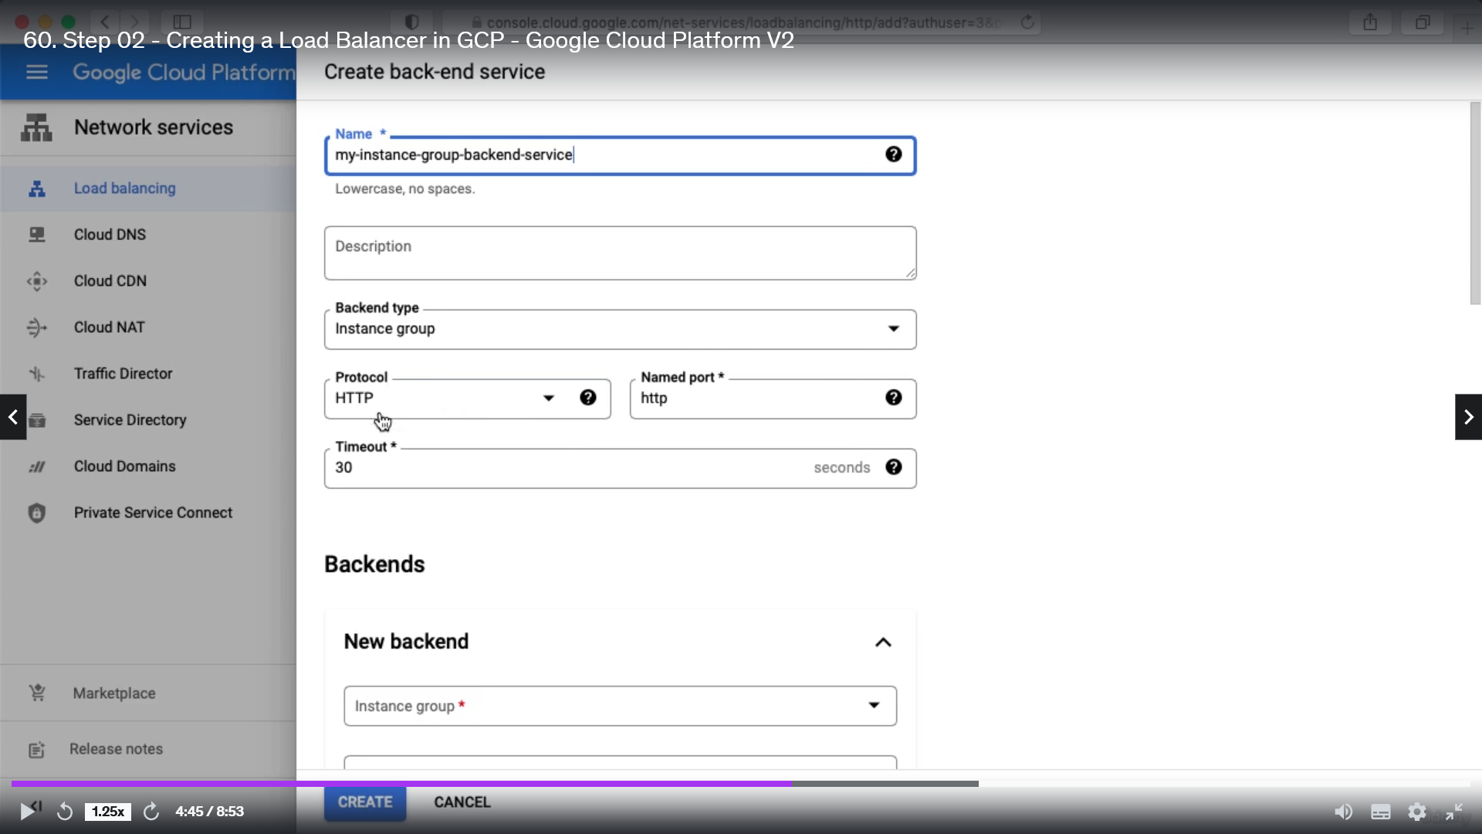

Also, you can choose the instance group

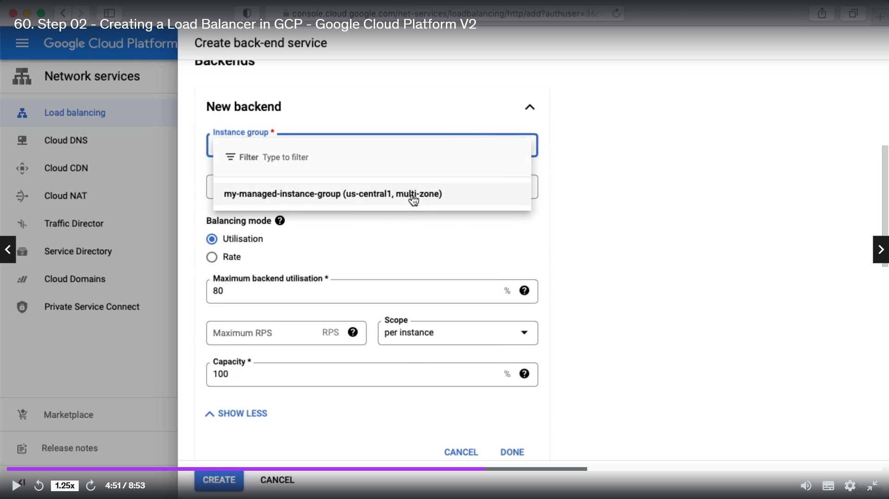

Also you can configure the port number

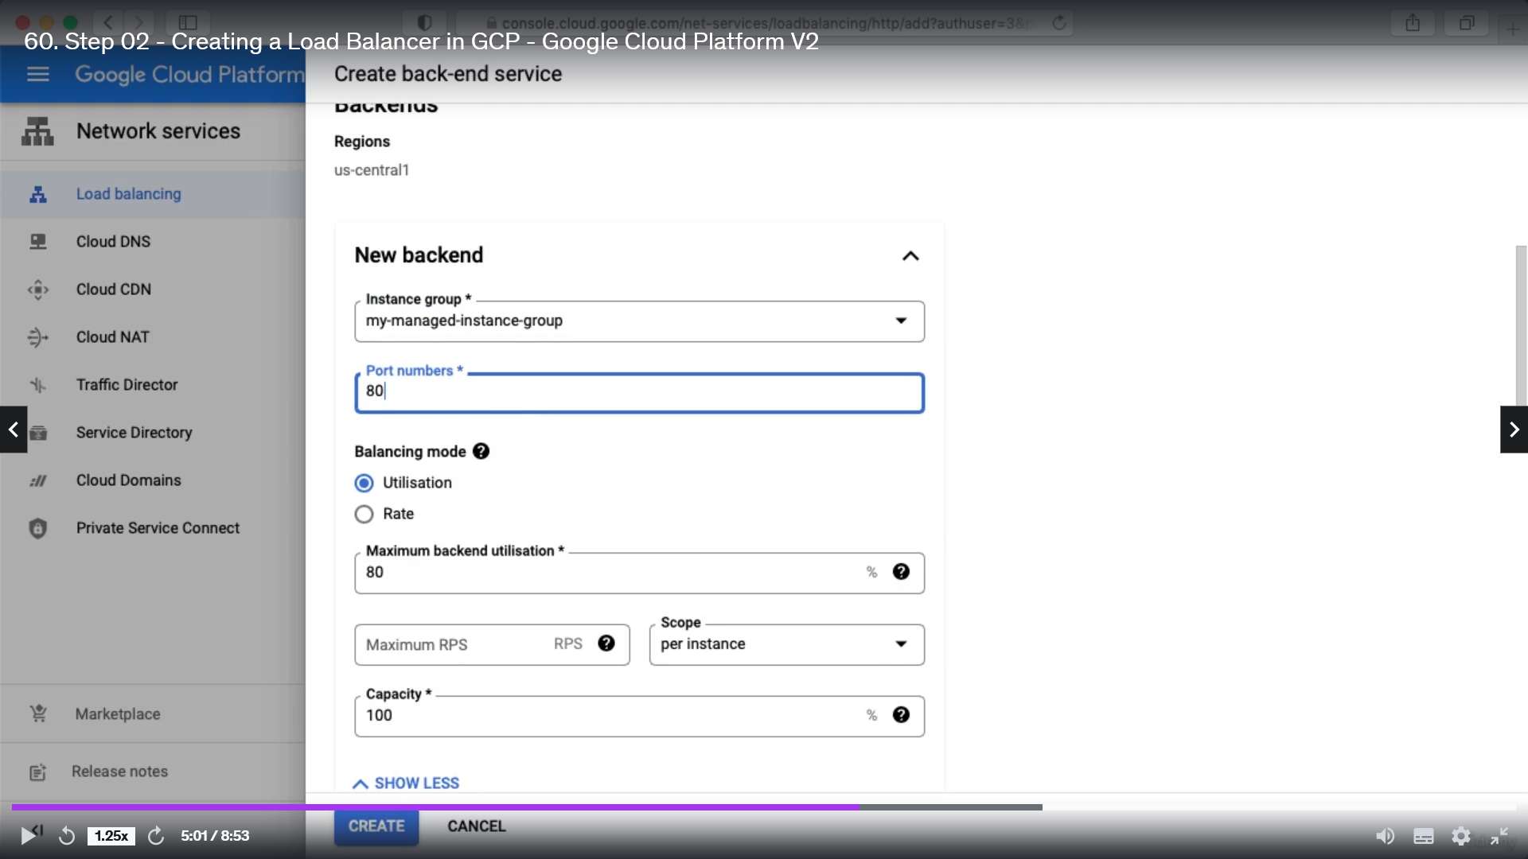

Click done to finish the Backend configuration.

You can check Enable Cloud cdn to catch static content line static html page

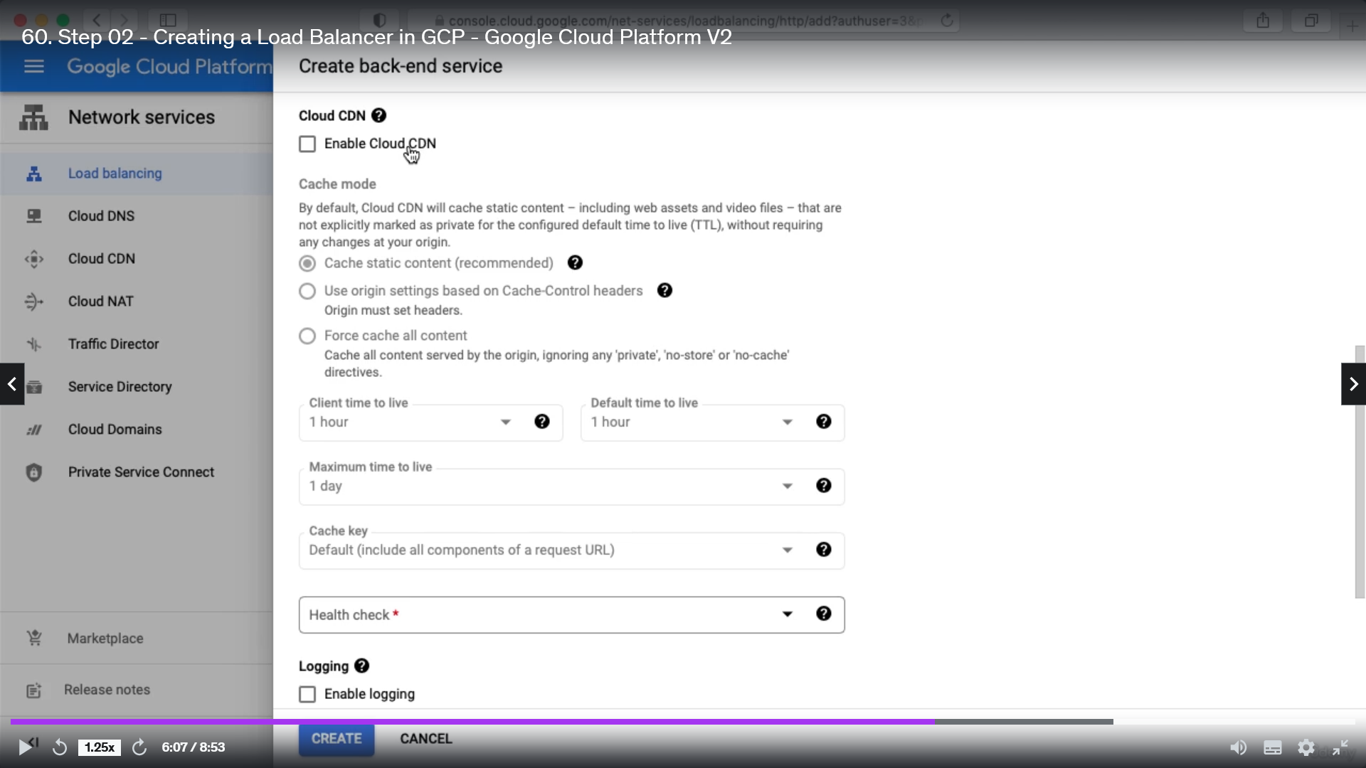

Add a health check

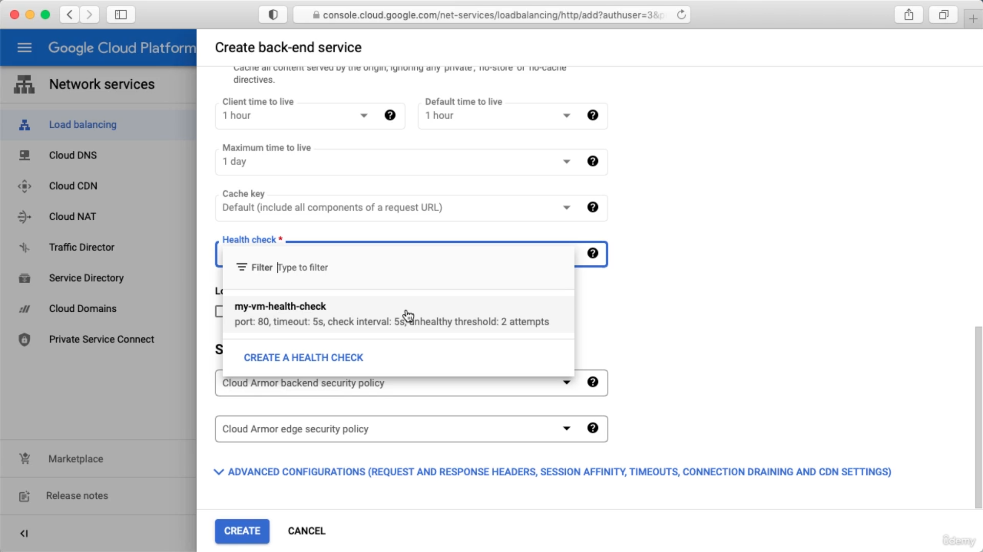

Click create.

Next we need to configure Host and path rules, this decides how your traffic will be redirected to backend.

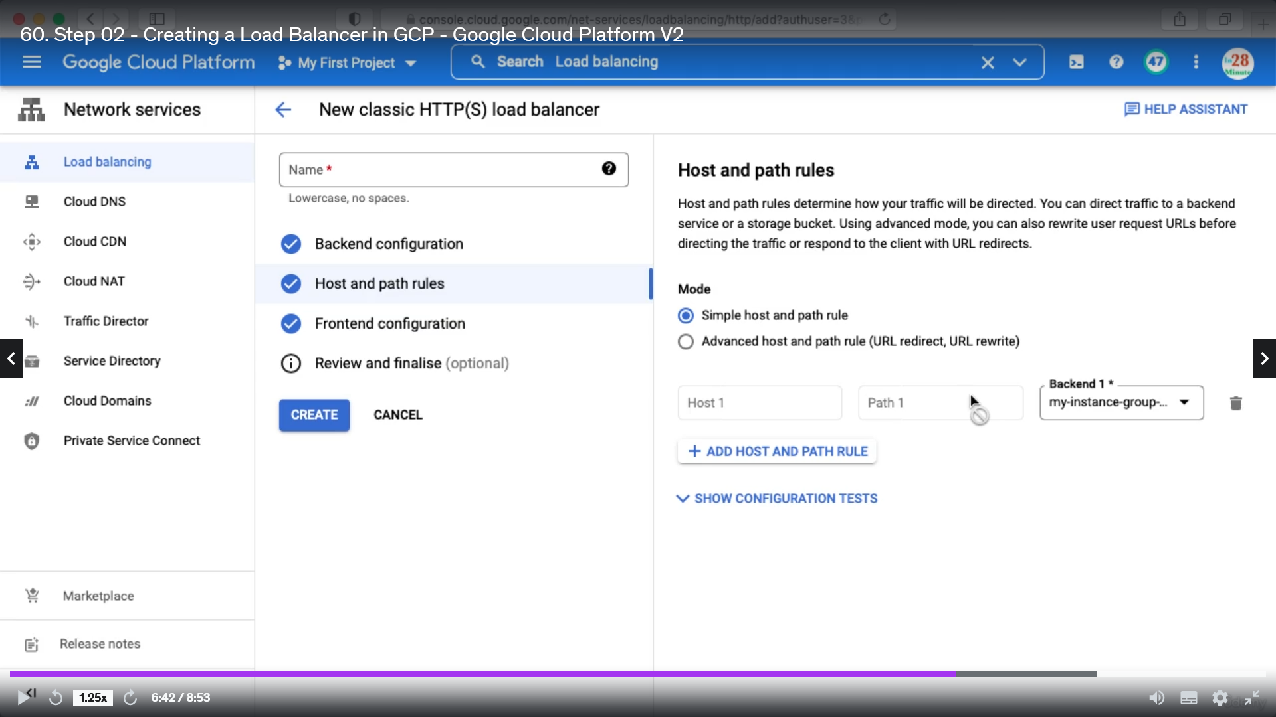

Here we can configure different backend services based on different path

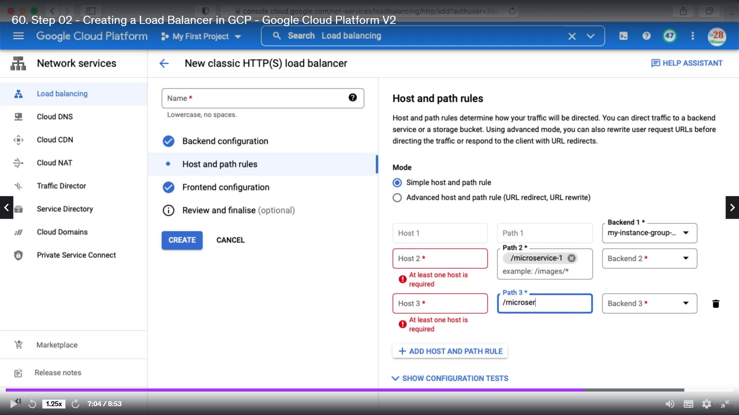

For our case it is as below, all the requests will route to my-instance group

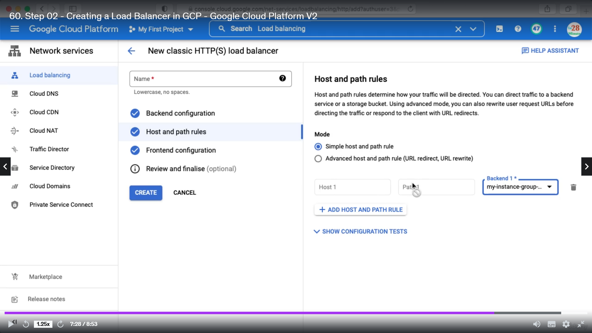

Frontend Configuration: Where you want to receive the request

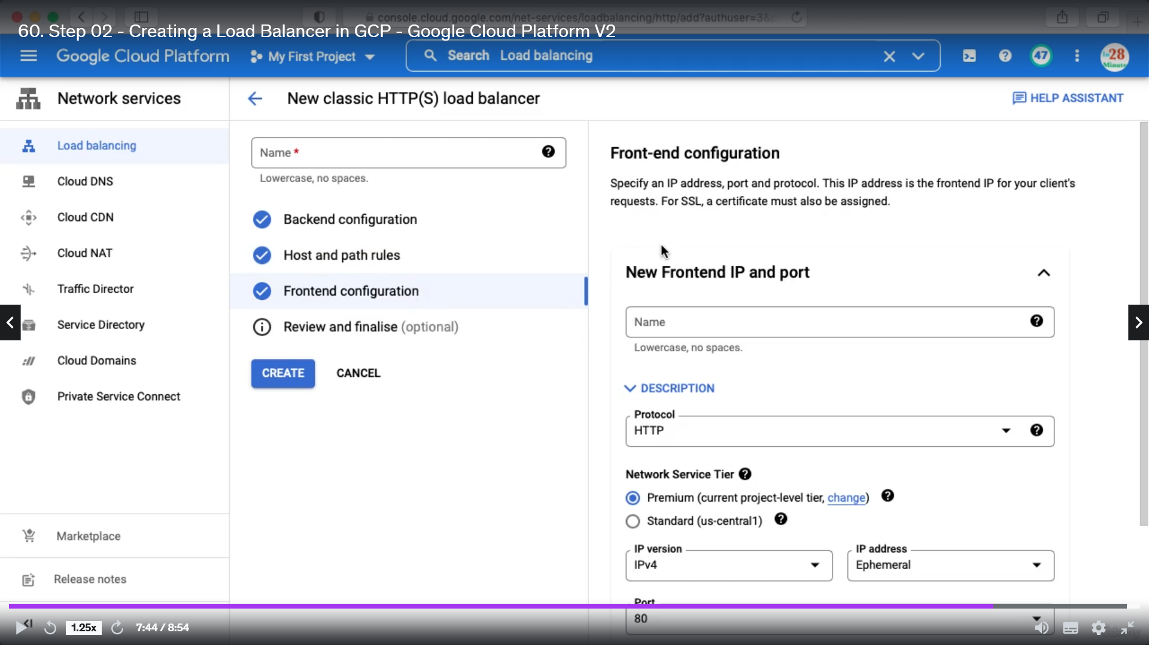

Next review and finalize the setup

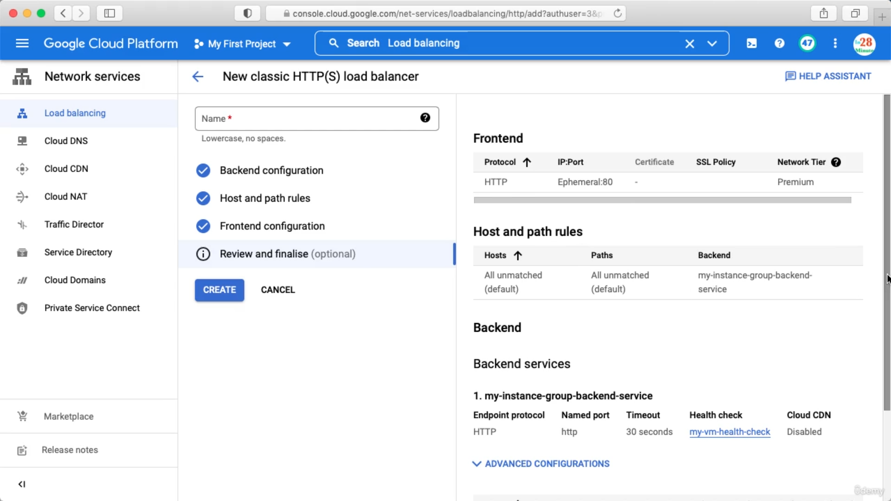

How to choose different Load balancer. Important for the exam

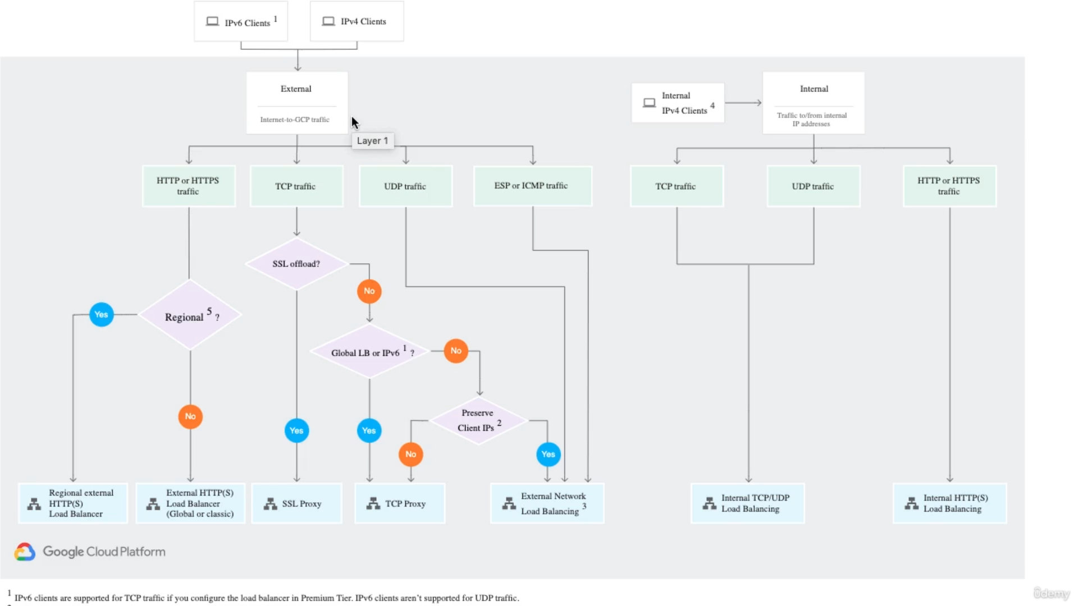

Proxy : whatever request comes load balancer does some changes and send to backend. Pass through means whatever comes this will pass to backend.